Document Cover Sheet

Project Number | PN-3-XXXX (leave blank if unknown or not applicable)
Document Title | ATIS Task Force report recommendations for TIA-5050 revision
Source | Samsung
Contact | Name: Robert Kubik, Rehan Ehsan  Complete Address: 700 Pennsylvania Ave Suite 600  Washington DC 20006 |  | Phone: 202-236-5697  Fax:  Email: Robert.kubik@samsung.com, rehan.ehsan@sea.samsung.com
Distribution | TR-41
Intended Purpose of Document  (Select one) |  | For Incorporation Into TIA Publication
 |  | For Information
 | X | Other (describe) – For the work of TR-41 VCTG
“The document to which this cover statement is attached is submitted to a TIA Engineering Committee, Formulating Group, or sub-element thereof in accordance with the provisions of TIA procedures including but not limited to Section 3.3.2 of the TIA Engineering Committee Operating Procedures, all of which provisions are hereby incorporated by reference.”

Abstract

The ATIS HAC Task force report provide recommendations for the work on the revision to TIA-5050. This contribution highlights those recommendations.

Introduction
The HAC Task Force noted that little testing data was available for review to understand how current devices perform relative to the 2019 ANSI Standard, which the Commission incorporated into its HAC rule during the course of the HAC Task Force’s work. Accordingly, the HAC Task Force formed WG3 to examine the impact of changes of the 2019 ANSI Standard and related Commission rulemaking on the HAC Task Force charter and work (i.e., achievability of 100% hearing aid compliance).
Handset manufacturers participating in WG3 agreed to perform testing and submit that data for evaluation. The working group received data about eighteen mobile handsets, which were tested using the 2019 ANSI Standard procedures. WG3 found that none of the handsets were able to pass all testing, primarily because none of the handsets were able to pass the volume control clause of the standard.
After analyzing the probable reasons for the handsets not to pass the volume control clause, WG3 recommends that TIA reopen the TIA 5050 standard for revision regarding (i) receive distortion and noise performance (ii) acoustic frequency response and (iii) consideration of codecs with speech bandwidth exceeding 50-7000 Hz.
WG3 estimates that revising the volume control standard can be done relatively quickly, but recognizes that the ANSI C63.19 committee would then need to accept the standard and petition for a rulemaking, and the Commission would update the technical standard in the rules. In order to enable handsets to pass the Commission’s requirements for near-term testing to the 2019 ANSI Standard, WG3 recommends that the Commission modify requirements associated with volume control testing until TIA can complete the revisions to the standard. If TIA cannot come to a resolution of testing of codecs with bandwidth exceeding 50-7000 Hz, WG3 recommends the Commission exclude those from compliance testing.

Further Analysis on Volume Control.
WG3 determined that signal-to-distortion-and-noise ratio (“SDNR”) using a pulse noise (“PN”) test signal was a key factor in devices failing to pass the volume control requirement and led to all devices not meeting the C63.19-2019 testing criteria. Further, a high failure rate for acoustic receive frequency response could also be a significant issue with passing C63.19-2019 testing criteria. WG3 also notes that TIA 5050 does not take into account super wide band codecs.
The intent of distortion and frequency response in TIA 5050 is to ensure the audio amplifier/speaker combination can reproduce speech signals at the required volume with little distortion and while maintaining a specified frequency response within certain limits

PN-SDNR Further Test Data.
Additional evaluation of the test data provided details of measurements of PN-SNDR at the evaluation channels for Adaptive Multi-Rate (AMR) and Enhanced Voice Services (EVS) codecs. This test data was produced following TIA 5050.
One OEM provided test data set shown in Figure 20, this data (data set 1) is measurement results for three devices in each 1/3 octave band center frequency from 250-5000 Hz for both an AMR wideband codec and EVS wideband codec. Results indicate that the EVS codec does pass the 20 dB criteria but it has a very low margin at 800 Hz, 3150 Hz, and 4000 Hz. The AMR codec fails testing above 1250 Hz and has very low margin at 250 Hz, 800 Hz and 1250 Hz.
Figure 20: Test data set 1
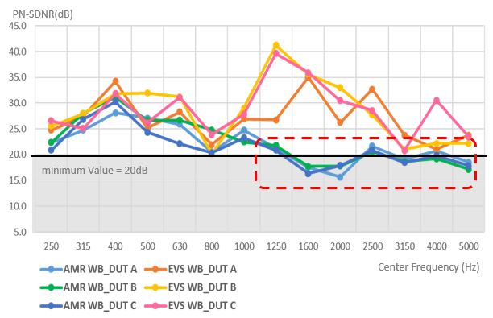

Another OEM provided test data shown in Table 6 and Table 7. This data (data set 2) is from one device showing test results for AMR narrowband and wideband codecs as well as EVS narrowband and wideband codecs. Testing results show that the ability to meet the test criteria of TIA 5050 is heavily dependent on which codec is used, e.g., the PN-SDNR in EVS modes could be 5-10 dB higher than in AMR modes. Further, PN-SDNR could drop by 5-10 dB for frequencies above 1000 Hz in AMR codecs and for frequencies above 3150 Hz in EVS codecs.
Table 6: Narrowband Codec Test Data
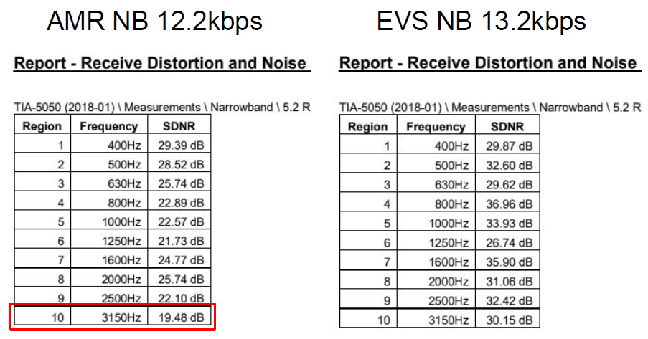
Table 7: Wideband Codec Test Data
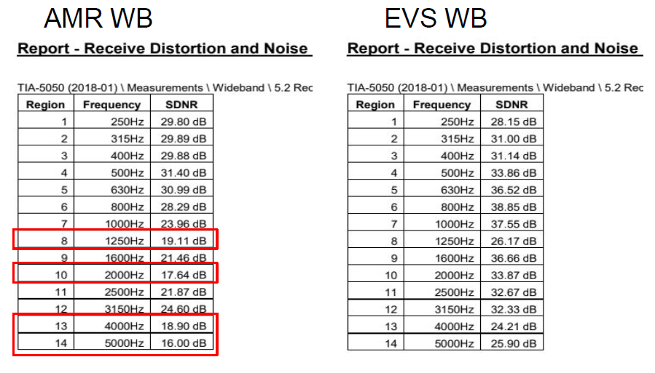
Data set 2 also provided the waveforms captured by the logging tool to compare the vocoder data after speech codec decoding without audio processing. The data shows a real speech signal at the 1/3 octave band followed by the PN-SNDR signal with-in the same 1/3 octave bands, this is repeated for all 1/3 octave bands from 250-5000Hz. The data shows pulsed noise stimulus signal level in AMR wideband codec is about 3-7 dB lower than that in the EVS wideband codec for frequencies above 1000 Hz. The finding is that the PN-SNDR is heavily dependent on the speech codec characteristics, getting smaller as a result of the smaller measured stimulus amplitude.
A further analysis (data set 1) was done to evaluate AMR and EVS wideband codes through simulation. In this instance each codec was analyzed through computer simulation using the pulsed noise signal. Shown in Figure 21 are the results for 1/3 octave at 1250 Hz and 5000 Hz. Signals for the AMR codec show increased noise around the center frequency and distortion on the main signal that is not seen with the EVS codec.

Figure 21: Computer simulation of AMR and EVS wideband codecs to pulsed noise signals. Yellow line is data captured for the EVS codec and blue line is for the AMR codec.
1250 Hz | 5000 Hz
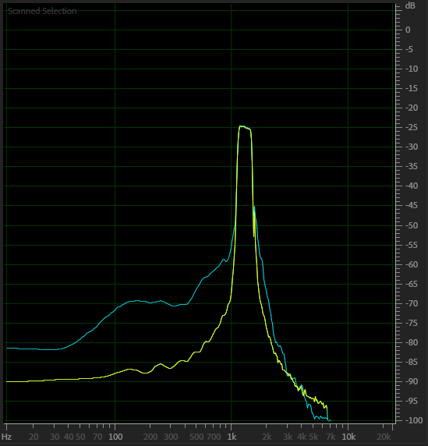 | 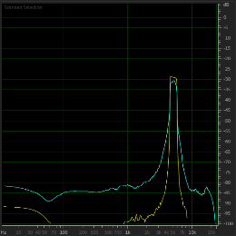

The characteristics of each codec were analyzed by the receiving audio pack of the device that includes the influence of the network codec and the mobile device. Shown in Figure 22 is the time domain signal in the top set of graphs with the corresponding frequency response of the respective codecs in the bottom set of graphs. Pulsed noise passes through the AMR codec and produces unintended noise and distortion of the signal.

Figure 22: EVS and AMR wideband codec Frequency Response to speech and Pulsed Noise. Red is AMR wideband codec and green is EVS wideband codec
Speech | Pulsed Noise
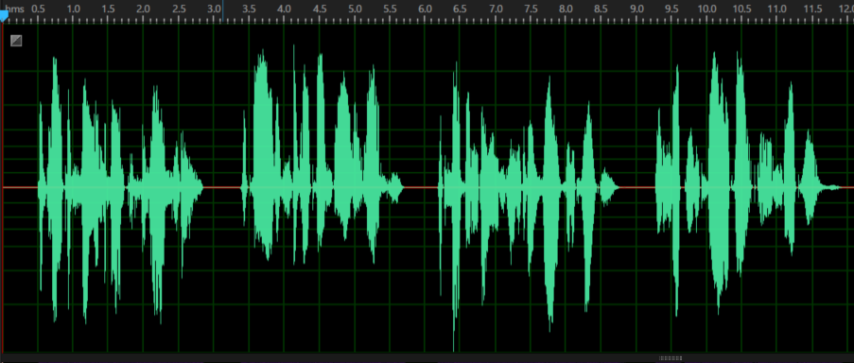 | 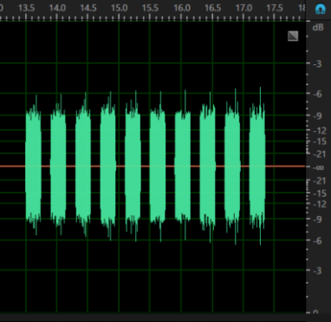
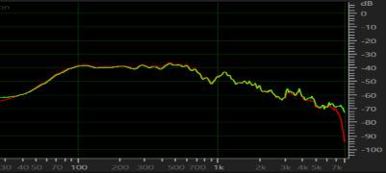 | 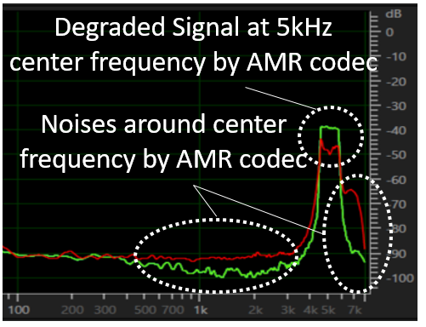

Acoustic Receive Frequency Response.
WG3 data found that a significant number of devices did not pass acoustic receive frequency response testing. WG3 notes that there is a significant difference between the TIA standards and 3GPP standards used to produce the frequency response.
Shown below in Figure 23 is the test data using the TIA 5050 testing guidance as well as the test data using the 3GPP standard TS 26.132 Section 5.1. The difference is the filter used to transform the drum reference point spectrum measurement to the far field (FF) or diffuse field (DF). Figure 24 below shows the two transforms.
WG3 recommends that TIA 5050 be aligned with 3GPP standard TS 26.132.
Figure 23: TIA 5050 and 3GPP Acoustic Receive Frequency Response
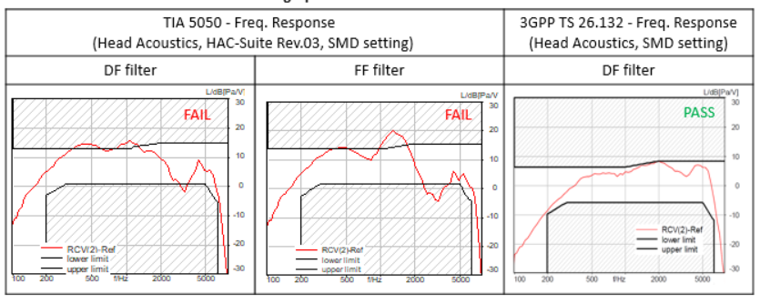

Figure 24: TIA 5050 and 3GPP TS 26.131 DF Filter
TIA 5050 - Freq. Response DF filter  (Head Acoustics, HAC-Suite Rev.03, SMD setting) | 3GPP TS 26.131 - Freq. Response DF filter  (Head Acoustics, SMD setting)
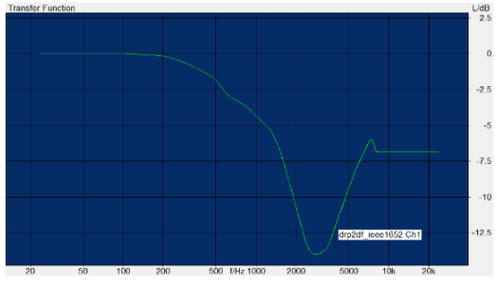 | 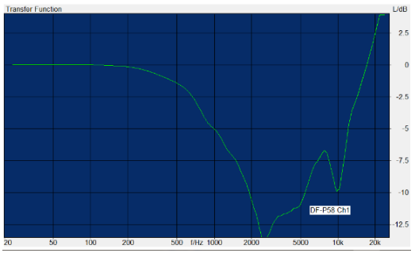

Intent of Volume Control.

Distortion and Frequency Response.
The 2019 ANSI Standard volume control requirements come by reference to TIA 5050. However, the Commission’s requirement that handsets pass TIA 5050 for all combinations of available codec and air interface is not in line with the original intent of TIA 5050. The technical issue being addressed by TIA 5050’s distortion and frequency response requirements is that the handset has an amplifier/speaker combination that can produce a loud enough speech signal without unacceptable distortion and frequency response deviation.
Essentially, the testing is to ensure that the audio amplifier/speaker combination can reproduce speech signals at the required volume with little distortion and while maintaining a specified frequency response within certain limits. TIA 5050 tests were developed for this purpose. Its tests were not intended to be used to validate the quality of electrical transmission of the codec (or air interface) itself. The standard’s developers did not attempt to fully resolve the technical difficulty of developing a test signal with speech-like characteristics that could pass substantially unchanged through all possible speech codecs, or that would evaluate the end-to-end transparency of the various speech codecs. However, if the acoustic output distortion and frequency response requirements are met with the specified test signal for at least one codec/air interface combination, then the test device’s audio amplifier/speaker combination should have similar output capability for all codec/air interface pairings.
In that spirit and until the standards process concludes, a reasonable interim proposal would be that the distortion and frequency response measurements would be performed using any one codec and air interface, which would show that the amplifier/speaker does not cause unacceptable distortion and frequency response deviation. TIA 5050 specifies that testing is to be done using any air interface, but only the AMR codec. TIA 5050 could be simply modified or reinterpreted to allow any codec and air interface combination for the distortion and frequency response measurements.

Conversational Gain.
Separately, there is the question of whether for each codec/air interface combination, the required volume levels can be achieved (conversational gain). The discussed difficulties with testing distortion and frequency response do not appear to be present with this test, so requiring conversational gain testing for all combinations of codec and air interface should not be problematic.
A high failure rate in this test at the 8N force indicates a potential issue that should be investigated further. However, the 2N test is the more relevant aspect of the standard for hearing aid use, which is the subject of the 2019 ANSI Standard. Therefore, a reasonable interim proposal until the standards process concludes would be that the conversational gain measurements would be performed for all combinations of codec and air interface only at the 2N application force, as this represents the hearing aid use case.

Additional Considerations and Notes.
WG3 observed that wireless handsets are typically tuned and adjusted by manufacturers, in advance of and potentially during certification testing, in order to optimize audio and RF characteristics to meet the specific requirements of the standard being used. However, since the wireless handset samples used during the WG3 study were representative of the models certified to the previous 2011 version of the C63.19 standard, they were not tuned or adjusted by manufacturers for the 2019 version of the standard. WG3 noted that while some characteristics are inherent to the handset, other characteristics such as audio gain or frequency response shaping may be within the scope of manufacturer tuning.
The Commission’s testing approach adds test requirements for Volume Control, as compared to the approach taken in the adopted standard, where testing is based on supported codecs rather than channels, bands, and air interfaces:
A mobile handset must meet the volume control requirements on all air interfaces as required by §20.19(b)(3) which states, “a handset is hearing aid-compatible if it meets the 2019 ANSI standard for all frequency bands and all air interfaces over which it operates.” This guidance does not require every combination of codec, codec data rate, air interface, band, band channel, bandwidth, modulation data rate, subcarrier spacings, and resource blocks to be documented in a test report. However, it is expected to investigate and document only the worst-case test conditions and results. Each submitted test report shall document the codec type (i.e., NB, WB, EVS, etc.), every air interface (i.e., LTE, 5G NR, WI-FI), and band supported for the worst-case codec bit rate, band channel, bandwidth, air interface bit rate, subcarrier spacings, and resource blocks, for the handset to be considered compliant to §20.19(b)(3).
To be compliant, at least one volume control setting must meet the test requirements with a mounting force at both 8N and 2N.
In this WG3 investigation, test channels and bands were typically selected based on worst-case RFE or T-Coil result from certification testing to the 2011 ANSI Standard. A low passing rate for Volume Control was observed for selected channels.

Conclusions and Recommendations.
WG3 received data from eighteen mobile handsets, which were tested using the procedures of the 2019 ANSI Standard. WG3 found that none of the handsets were able to pass all testing. The key factor driving this observation is the inability of handsets to pass volume control testing. After further analysis on the volume control data, WG3 provides recommendations for TIA and the Commission.
WG3 recommends that TIA reopen the TIA 5050 standard for revision regarding (i) receive distortion and noise performance (ii) acoustic frequency response and (iii) consideration of codecs with speech bandwidth exceeding 50-7000 Hz. Specifically, TIA Should Re-Open the TIA 5050 Standard – Mobile industry should lead this work and as a starting point for the work, below are proposed revisions for consideration.
- PN-SDNR Test Signal Interaction with Speech Codecs – TIA should decide how best to resolve issue noted above for PN-SDNR testing, below are three options for consideration.
  - Adjust the performance criteria – Revise the PN-SDNR limit from “≥ 20 dB” to “≥ 10 dB” for the test frequency bands over 1 kHz for all codecs. Below 1 kHz PN-SDNR limit should be revised to “≥ 15 dB.
  - Change the test signal and performance criteria – Consider adoption of test methods and criteria found in 3GPP TS 26.131 section 6.8 and TS 26.132 section 8.8. Noting that the 3GPP standard only tests to 1040 Hz, TIA should consider criteria above higher frequencies when applying the 3GPP standards as necessary to ensure adequate performance with hearing aids.
  - Consider the use ITU-T P.863 POLQA MOS-LQO score to replace PN-SDNR – Consider adoption of speech signals and POLQA MOS-LQO score defined in the ITU-T P.863 Recommendation. TIA should evaluate the appropriateness of using the POLQA MOS-LQO metric and ensure any POLQA MOS-LQO performance criteria selected provides acceptable audio quality.
- Acoustic Receive Frequency Response – Use 3GPP TS 26.132 Section 5.1 to transform Drum Reference Point (DRP) frequency spectrum measurement to the Free Field (FF) or Diffuse Field (DF) in place of Annex B of TIA 5050. This would lead to changes in TIA 5050 in Annex B, point 5 of section 5.3.2.
- Testing of Codecs with Speech Bandwidth Exceeding 50-7000 Hz
  - Expand the Scope of TIA 5050 to be Consistent with Commission Guidance – Industry notes the standard scope considers narrowband (speech bandwidth of 300-3400 Hz) and wideband (speech bandwidth of 50-7000 Hz) codecs and conflicts with OET guidance. TIA should expand the scope and criteria to consider codecs with speech bandwidth exceeding 50-7000 Hz.
  - Limit the Frequencies Tested for Codecs with Speech Bandwidth Exceeding 50-7000 Hz – Noting the performance of hearing aids is limited in frequency range there may not be a need for testing codecs with speech bandwidth exceeding 50-7000 Hz beyond the frequencies already specified in TIA 5050.
- Investigation of the high failure rate for 8N conversational gain when 2N conversational shows a low failure rate

See 2021 HAC Standard Order, 36 FCC Rcd 4566 (incorporating the 2019 ANSI Standard into the Commission’s rules and transition the HAC testing standard to the 2019 ANSI Standard).
ANSI/TIA-5050-2018, Receive Volume Control Requirements for Wireless (Mobile) Devices (Jan. 2018).
The Chief of the Wireless Telecommunications Bureau and the Chief of the Office of Engineering and Technology may also update the incorporated ANSI standard. 47 C.F.R. § 20.19(k)(2).
See Section 5.6.
Adaptive Multi-Rate Codec, https://en.wikipedia.org/wiki/Adaptive_Multi-Rate_audio_codec (last visited Nov. 7, 2022).
Enhanced Voice Services, https://en.wikipedia.org/wiki/Enhanced_Voice_Services (last visited Nov. 7, 2022).
The table numbers and figure numbers are unchanged from the ATIS Task Force report.
The test setup used HEAD acoustics HAC-Suite (code 60021) and R&S network simulator CMW500 (AMR and EVS speech codecs).
FCC, OET, KDB 285076 – HAC Guidance v06r01 Section 2 (Oct. 25, 2022), https://bit.ly/3hDX1yZ.
Depending on the option TIA pursues, WG3 notes that conforming edits to the hearing-aid testing may be required.

