Chair: | Andy Davis, Motorola Solutions, Andy.Davis@motorolasolutions.com
Vice Chair: | Derek Wells, L3Harris Technologies, derek.wells@l3harris.com
TIA Staff: | Victoria Mitchell, vmitchell@tiaonline.org, +1.571.215.1858
Meeting Dates: | 12-14 July 2022
Time: | See Meeting Schedule
Location: | Holiday Inn Memphis Downtown Beale Street  160 Union Avenue  Memphis, TN 38103  Phone: +1-901-525-5491  Website
Meeting Room: | ”Memphis Ballroom” – main meeting room  “Memphis Boardroom” – office you’re welcome to use
Room Rate: | $149/single or double (plus all applicable taxes, $2/night occupancy tax)  Please Note: Government rates are also being honored.
Reservation Information: | Online reservations can be made at this URL. When booking a room through this link, all of the information will default as needed to ensure you get our $149/night rate. You’ll need to only change your Check-In and Check-Out dates.  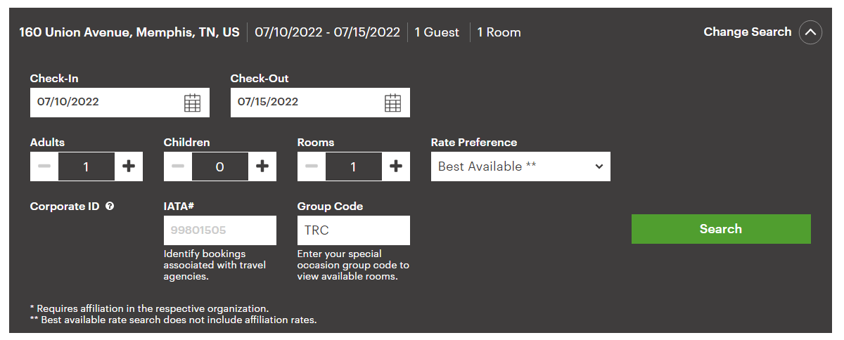  If you plan to call in your reservation:  Toll Free: 1-877-666-3243 or 800-465-4329 (preferred)  Local Phone: +1-901-525-5491  Please be sure and reference “TR-8” to ensure you’re included in our room block and receive the contracted rate.  If you’ll be booking through a government rate, please call the number above.
Cut-Off: | ASAP
Check-In/Check-Out | Check-in time is 3:00pm (local)  Check-out time is Noon (local)
Cancellation Policy: | No penalty for reservations cancelled up to 24 hours before check-in. If you cancel your reservation, make sure you receive a cancelation number.
Miscellaneous Information: | Overnight Parking - $25
Contribution Location: | https://connect.tiaonline.org/communities/community-home/librarydocuments?LibraryKey=5493cc98-ab3c-4ae0-8acb-6ebe7431faf8

