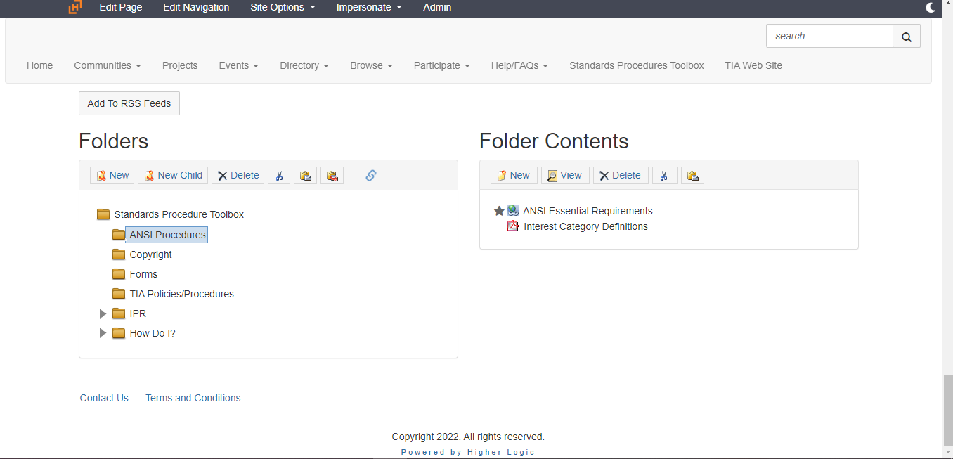

Standards Procedure Tool Box- ANSI Procedures- Interest Categories

