Document Cover Sheet

Project Number | PN-3-XXXX (leave blank if unknown or not applicable)
Document Title | HAC Task Force WG3 Recommendation - adoption of POLQA MOS-LQO score to replace PN-SDNR
Source | ATIS / Google / ITU-T
Contact | Name: Owen Wu  Complete Address: No. 23, Xinghua Rd., Taoyuan Dist., Taoyuan City 330 , Taiwan (R.O.C.) |  | Phone: +886287290279  Fax:  Email: owenwu@google.com
Distribution | TR-41
Intended Purpose of Document  (Select one) |  | For Incorporation Into TIA Publication
 | X | For Information
 |  | Other (describe) -
“The document to which this cover statement is attached is submitted to a TIA Engineering Committee, Formulating Group, or sub-element thereof in accordance with the provisions of TIA procedures including but not limited to Section 3.3.2 of the TIA Engineering Committee Operating Procedures, all of which provisions are hereby incorporated by reference.”

Abstract

Hearing Aid Compatibility Task Force Work Group 3 recommended that TIA should consider adoption of POLQA MOS-LQO score defined in the ITU-T P.863 Recommendation to replace PN-SDNR. TIA TR41 committee can use this submission as reference for VC Task Group to evaluate the appropriateness of using the POLQA MOS-LQO metric and ensure its performance criteria selection provides acceptable audio quality for the further revision of TIA-5050 standard - ANSI/TIA-5050-2018.
- Background and Industry Status
The purpose of PN-SDNR (Pulsed Noise Signal-to-Distortion-and-Nosie Ratio) metric in TIA-5050 is to determine the ratio of signal to distortion and noise power through the Pink Noise. It also represents the audio/acoustic signal quality outputted from wireless handset telephones to hearing aid devices. Recently, handset telephone industry have implemented some noise reduction solutions to suppress the downlink background noise from far-end side to offer more clear voice in handset’s earpieces for near-end users. It also improved the recognition in communication a lot in voice quality when users are using telephony calls.
- Difficulty of using PN-SDNR
PN-SDNR’s test source defines to use Pulsed Pink Noise that is also a kind of noise, so the noise reduction algorithm of handsets (de-noisier) will treat it as a kind of Background Noise and suppress it when we measure PN-SDNR. It will cause the test signal attenuation and degradation to get failed results of PN-SDNR measurements because the SNR is lower after processing. In practice, Pulsed Pink Noise might not be comprehensive enough to represent the real speech quality that handsets can offer to end users.
Fig.1a and Fig.1b are the time-domain waveform analysis from the logging data captured when we measure PN-SDNR for our handset products by using Head acoustics ACQUA with HAC-Suite Code 60021 for TIA-5050. From the illustration of Fig.1b, the de-noisier does NOT attenuate Real Speech during PN-SDNR testing, but the de-noisier does attenuate Pink Noise signal to result in about 20dB amplitude loss compared to the Fig.1a. The noise suppression algorithm caused PN-SDNR results degraded and failed the criteria that shall be over 20dB.
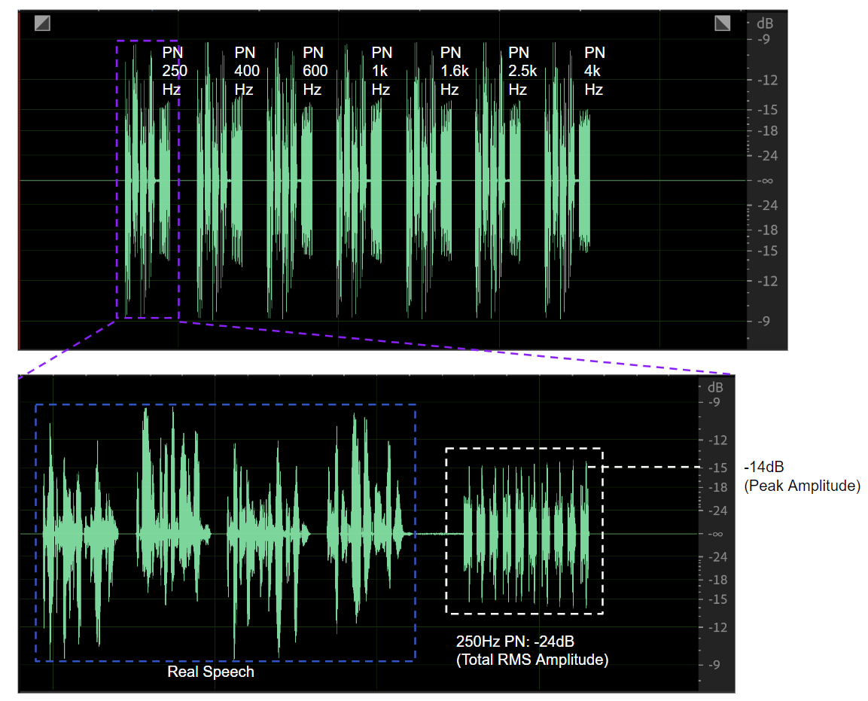
Fig. 1a - Speech and Pink Noise without Noise Reduction Processing
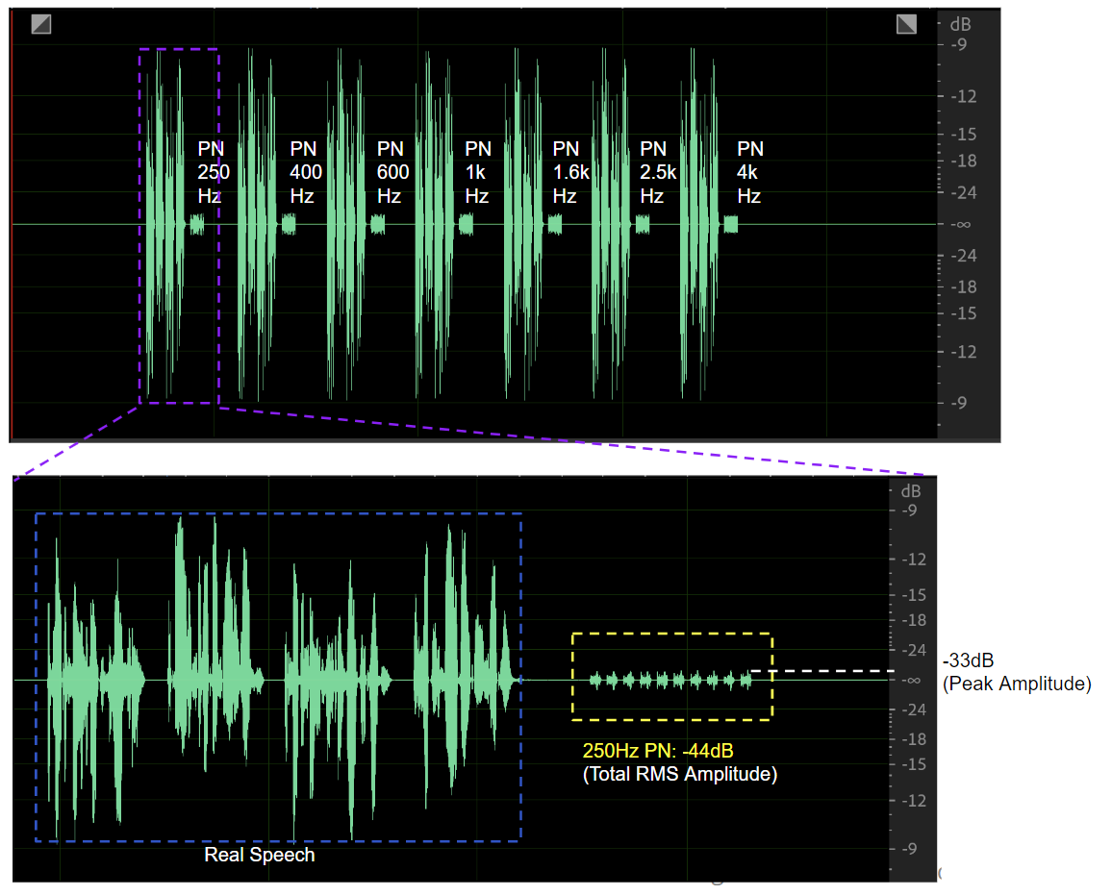
Fig. 1b - Speech and Pink Noise after Noise Reduction Processing

As a result, using Pink Noise as the test signal to determine voice quality of handset outputs would not be overall for the handset telephones that tend to enhance their noise suppression capability.

- Advantage of using the POLQA MOS-LQO metric
The POLQA score offered a Perceptual Objective Listening Quality Prediction methodology for assessing the speech quality of current and near future telephony systems that utilize a broad variety of coding, transport and enhancement technologies. Its application included distortions and all speech codecs form narrowband (NB) (300 to 3.4k Hz) to full-band (FB) (20 to 20kHz ) telecommunication scenarios. Its test set database covers many languages: American English, British English, Chinese(Mandarin), Czech, Dutch, French, German, Italian, Japanese, Swedish, and Swiss German. Its algorithm was tested on a wide range of test conditions and distortions and provides a very good tool for predicting subjectively determined MOS scores.
POLQA scores tended to define an objective measurement metric for voice telephony designer to evaluate subjective listening efforts in laboratory environment. The voice signal outputted from handsets more close to the original test signal without distortion/speech-loss/clipping, and then the higher POLQA MOS scores the handsets can get in the testing. From telephony-voice-quality point of view, it can provide a good metric for determination of how the voice quality handsets offer to People with or without Hearing Loss.

Based on the pros of previous above, taking POLQA MOS-LQO as the requirement metric for voice quality determination is more realistic/better than PN-SDNR for users with or without hearing impaired.

- Requirement Recommendation for using POLQA MOS-LQO to replace PN-SDNR
  - The maximum ITU-T P.863 POLQA MOS-LQO score is 4.5 for listening over loosely coupled IRS type handsets.

  - Some Handset Mode POLQA requirements defined by N.A. Carriers for reference:
- T-Mobile US: MOS ≧ 3.2 for NB and WB; MOS ≧ 4.0 for SWB (AMR & EVS codecs)
- Canada TELUS: MOS > 3.04 for NB; MOS > 3.33 for WB; MOS > 3.61 for SWB (AMR & EVS codecs)
  - Some measurement results of Google’s handsets for reference

AMR-NB | Bitrates(kbps) | 4.75 | 5.9 | 12.2
 | POLQA MOS | 3.3 | 3.6 | 4.1
AMR-WB | Bitrates(kbps) | 6.6 | 8.85 | 12.65 | 23.85
 | POLQA MOS | 3.3 | 3.7 | 3.8 | 4.0
EVS-NB | Bitrates(kbps) | 5.9 | 9.6 | 13.2
 | POLQA MOS | 3.8 | 4.0 | 4.1
EVS-WB | Bitrates(kbps) | 5.9 | 9.6 | 13.2
 | POLQA MOS | 3.3 | 3.7 | 3.8
EVS-SWB | Bitrates(kbps) | 9.6 | 13.2 | 24.4
 | POLQA MOS | 3.7 | 3.8 | 4.1

  - Requirement Recommendation
Like audio bandwidth, the data bandwidth of the speech-encoded bit-stream can vary to improve the efficiency of the voice transmission and meet the requirements of the terminal device. The most common codec used for mobile networks (AMR-NB) has significantly reduced the bit rate from the 64 kbps bit rate on VoIP networks (with quality comparable to PSTN) to rates of 5.90 to12.20 kbps via lossy compression techniques based on perceptual coding. AMR-WB also supports a range of bit rates from 12.65 to 23.85 kbps. Low bit rate connections have benefits in terms of decreasing telecommunications costs and increasing service availability, but there is a speech quality trade-off to induce different PLOQA MOS scores in different bit-rated speech codecs.
Some investigation results showed that higher bit rates produced better speech quality for both NB and WB audio than their lower bit rate counterparts. For AMR-NB/WB audio, a higher bit rate produced better speech recognition, and they really influence PLOQA MOS scores. Considering testing might be applied to handset’s all available speech codecs (i.e., FR, EFR, AMR, and EVS) with supported audio bandwidth(NB, WB, SWB) and supported data bit rates(i.e., 12.2kbps, 12.65kbps, and 13.2kbps), we propose the requirements below:

Bandwidth / Bit rate  (FR/EFR/AMR/EVS) | Equal to or higher than 12.2kbps | Lower than 12.2kbps
NB | MOS ≧ 3.8 | MOS ≧ 3.2
WB | MOS ≧ 3.8 | MOS ≧ 3.2
SWB | MOS ≧ 3.8 | MOS ≧ 3.2

